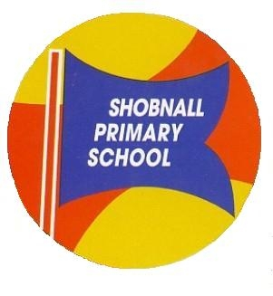

Shobnall Primary School, Shobnall Road, Burton upon Trent, Staffordshire, DE14 2BB

Telephone: 01283 239100 Facsimile: 01283 239105
e-mail: headteacher@shobnall.staffs.sch.uk

26th September 201600

Dear Parents,

DATA COLLECTION – CONTACT DETAILS

As you are aware we do our very best to care for your children throughout the day. When your child entered school you were asked to complete a Registration Form, as this enabled us to contact you in the unlikely event of an accident. There are also times when children become unwell and the emergency contacts you give us for the phone are also vitally important. The information is held on the school’s computer and access to this information is restricted. All information is treated with the utmost confidentiality.

Please be aware that with the introduction of our text messaging service, the text will only be sent to the first contact i.e. Priority number 1, on your sheet. If your contacts are not in the correct order of preference, please let us know and we will alter this for you.

In view of the necessity for the accuracy of this information we would like to please request that you check the details listed overleaf and amend any incorrect data and sign to say that you have had sight of this form.

Please return the form to the office by Monday 3rd October 2016

Thanking you in anticipation.

Free School Meals

Please try to claim for Free School Meals. School receives additional funding which we can then use for extra support in the classroom. Families who claim Child Tax Credit, (but not Working Tax Credit), with a household income of less than £16,190, maybe eligible for Free School Meals. It’s really quick and easy to apply, either online at www.staffordshire.gov.uk/freeschoolmealsapplication, or make an appointment with the School Office Staff. All appointments will be treated in the strictest confidence.

Yours sincerely

Mr R Cruise
Head Teacher

